Support Document

Incoming Orders

Solar 7

Document Version: | 1.0
Document Date: | 28 June 2011
Author | Sundar

Revision History Page

Date | Version | Description | Author
28 June 2011 | 1.0 | Initial Draft | Sundar
28 September 2011 | 1.1 | Revised Draft | Saurabh Luthra
10 October 2011 | 1.2 | Reviews Incorporated | Saurabh Luthra

Table of Contents
Table of Contents 3
1.Introduction 3
1.Scope 3
2.References 3
1.LIAB User Guide 3
3.Abbreviations 4
4.Orders 4
1.Introduction 4
2.Incoming Orders Process Overview 4
2.1.Block /Low level Diagram: 4
2.2.Low level steps: 4
3.EDI Exceptions 6
5.SQL Schema related to Incoming Orders 7
6.Useful SQL queries 8
7.Error/Log files: 8
8.Useful SQL queries 8

Introduction

Scope
This document is to give the reader an understanding of how Incoming Orders are processed in Solar7 and also the tables used in the LIAB database to store information related to Incoming Orders.
This document includes the complete business flow, with all the non-technical low level details that could be referred by the support team as an entry level document.

References

LIAB User Guide
Please refer the below URL to know more about how to use SOLAR7 screens and its features in detailed level.
http://elearning.specsavers.local/eLearning/userGuides/SOLAR_7_User_Guide_SOK_v10.0.pdf
P.S: Please list down all the reference used in this document here.

Abbreviations
Below is a quick reference list of abbreviations used in this document. For further details and explanation of these, please refer to the Supply Chain terminology & Definition document.
LIAB Lab in A Box
SGMB Specsavers Global Messaging Bus
EDI Electronic Data Interchange
P.S: Please list down all the abbreviations used in this document here.

Orders

Introduction
The order in Solar 7 can be created in two ways: EDI and Manual.

- EDI orders are received by SOLAR 7 through an electronic interface. Once received, the orders are validated and committed. Post confirmation orders can be seen in the Order Enquiry screen. If any orders have failed validation, then they will go into EDI Exceptions screen.

- Solar 7 also provides a screen for the manual creation of orders. With the help of this screen, the user can manually create an order with the required prescription. The Screen also provides options to validate the order and commit.

Incoming Orders Process Overview

Block /Low level Diagram:

Low level steps:
The Following are the overview steps which orders follow from Customer to SOK-SOLAR7.
- Stores send the orders to the labs in the form of RXE files. RXE messages are put on the “MessageRouter” queue configured on the Socrates broker. Socrates broker communicates with PLATO broker and passes the message to the “MessageRouter” queue of PLATO Broker. Messages are further delegated to the “Node {lab_num}” queue configured on PLATO Broker.

- Messages are routed to the corresponding labs via SGMB1/SGMB2.

- Orders from Legacy Labs are placed under folder /export/mail/inbox of LIAB server. The folder is configurable from the Lab Broker properties file. Labs broker (SGMB2) reads the order (RXE file) from the folder and creates a new row in edi_order_in table (Based on the active-mq.xml configuration).

- If a HO or Lab uses SGMB2, then the orders are directly placed under Active MQ queue. Labs broker reads the EDI order from the queue and creates a new row in edi_order_in table. (Based on the active-mq.xml configuration). The edi_order_in.sales_order_status_id will be 1, the RXE file contents will be in edi_order_in.data.

- Once the RXE files are processed, they will be moved to export/mail/processed folder and order status in “edi_order_in” table will be set to 1.

- If the Lab Broker is not able to process the .RXE. It will keep trying or it will moved to the problem queue.

- The EdiScheduler configured in SOLAR7, picks up unprocessed messages from the “edi_order_in” table of LIAB database. These records are identified as sales_order_status_id = 1 and sales_order_header_id is null. Each edi record will go though a number of validations:
  - that the order is not older than the configuration “edi order age limit”
  - the customer and delivery customer if necessary are validated
  - a blackbox validation on order
When the edi message has been successfully validated an order is created in solar7. The relevant sales order tables are populated. The edi_order_in record can be associated to a sales_order_header via the edi_order_in.sales_order_header_id.

- If the order fails validation, a validation error list is built and saved in edi_order_message, the edi_order_in.sales_order_status can be 10 (Invalid Order File), 7 (Invalide Account), 8 (Invalid Reference), 11 (Internal Error). A failed edi order can be seen in the Edi Exception pane.

- Once the order is picked by the SOLAR 7 application, the header information for the order goes into sales_order_header table and the prescription details for the same order goes into sales_order_detail table in LIAB database. The sales_order_header.edi will be true for an edi order.

- Whereas the manual order for solar7 can be created in the order screen, the details to create the order manually are mentioned in the above low level Diagram. sales_order_header.edi will be false

- When the manual orders are created, on pressing the validate button a web call is raised for the BB validation, if the validation fails then it displays error message on Order Entry Screen. This can be corrected allowing validation again.

- The request and response is stored in the blackbox_call_data table in the LIAB DB.

- For the EDI orders, if the orders are not validated then the orders can be seen as a new row in the EDI Exception screen. On pressing the order button against that row would redirect to the Order Screen

- It goes to the Order Screen, where the values are auto populated and are editable. Then the values can be edited and re- validated by pressing the validate button.

- Once the order (Manual/EDI) is validated, and if the order is surfaced then it goes for the surfacing calculation, if the surfacing calculation is successful then order goes to Awaiting Job Launch.

- If the surfacing calculation fails, then the order can be altered. This can be done in the order detail screen, go to the surfacing tab, press the recalculate button. The recalculate dialog will be enabled to allow the re-entering of the lens details, it can the be validated manually.

- If the order is a finished lens then that would directly go to the Awaiting Job Launch stage.

- Once the order is in the Awaiting Job Launch screen, then according to the configuration the desired order would arrive in the Glazing Job Launch or the Surfaced Job Launch screen. (If we are surfacing in house then the order goes to Surfacing Job Launch else goes to Glazing Job Launch)

- Then we need to go to the desired Job Launch screen and launch the order, the job ticket will be printed. Now the status of the order moves to Awaiting Pick, only when the stock check module in the configuration tab is set as true else the order moves to In Production.

- If the order status is Awaiting Pick then, we need to go to the Pick Confirmation Screen and enter the order reference number, left location and right location values from the surfacing job ticket and feed them into Left Lens Blank & Right Lens Blank respectively. Press Enter. Pick Confirmation message would be displayed on the screen and order moves to In Production.

- The further journey of the order would be described in the other documents.

EDI Exceptions
The EDI Exceptions screen will display all orders that have not been successfully committed in Solar7 and resulted in an EDI Exception. If an EDI order fails validation or due to internal/communication error, then the order status will be updated in edi_order_in table with error message. All the erroneous orders are listed in EDI Exceptions screen.

Orders can be amended individually to make changes and also there are options to retry or cancel in batches

Figure EDI Exception Screen

SQL Schema related to Incoming Orders
The tables interacting when an EDI order comes in are as shown below:
- Edi_order_in
- Edi_order_in_comment
- Edi_order_in_message
- Edi_order_in_summary
- Sales_order_status
- Sales_order_header
- Sales_order_details
- Sales_order_status_history
- Sales_order_summary

Schema Diagram
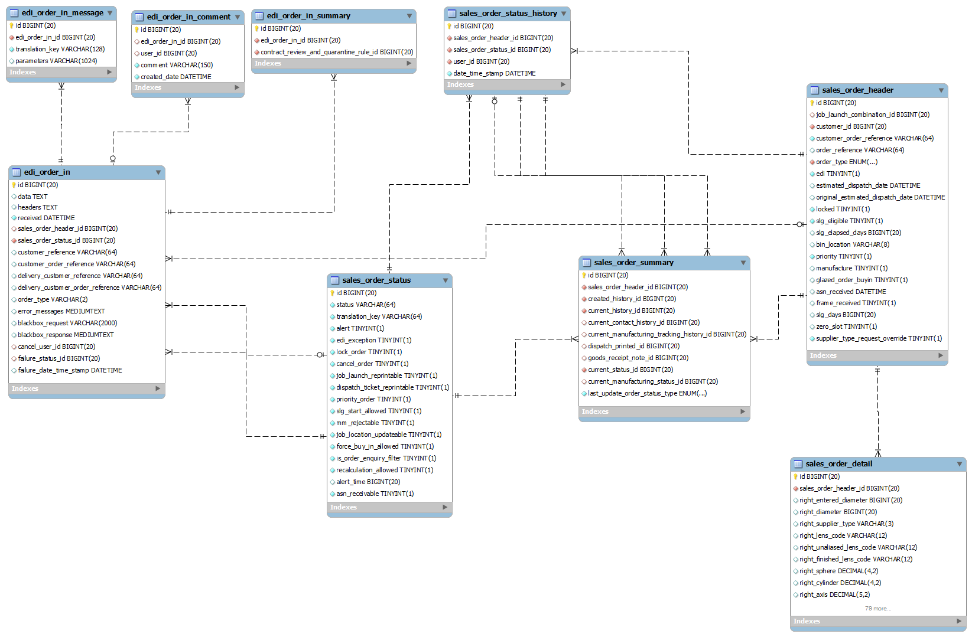

Useful SQL queries
To be updated by Dev/Support team.

Error/Log files:
The liab log file.
/tmp/liab.log
The Tomcat logfile.
/usr/share/tomcat5/logs/catalina.out
The blackbox log file
/tmp/blackbox.log
TO be updated with information from Dev team

Useful SQL queries
To be updated.

